**ALAGAPPA CHETTIAR GOVERNMENT COLLEGE OF**

**ENGINEERING AND TECHNOLOGY**

**(An Autonomous Institution Affiliated to Anna University, Chennai)**

**KARAIKUDI – 630003**

**PROFESSIONAL READINESS FOR INNOVATION**

**EMPLOYABLITY AND ENTERPRENEURSHIP**



IBM PROJECT REPORT

Submitted by

**Team ID: PNT2022TMID06083**

AKASH V 91761915005

MALATHY M 91762015206

RANJITH R 91761915028

NAVEENKUMAR E 91761915024

In partial fulfillment for the award of the degree

Of

**BACHELOR OF ENGINEERING**

**IN**

**COMPUTER SCIENCE AND ENGINEERING**

**NOVEMBER 2022**

**ALAGAPPA CHETTIAR GOVERNMENT COLLEGE OF**

**ENGINEERING AND TECHNOLOGY**

**(An Autonomous Institution Affiliated to Anna University, Chennai)**

**KARAIKUDI – 630003**

**BONAFIDE CERTIFICATE**

   Certified that this PROJECT REPORT **“IoT Based Safety Gadget for Child Safety Monitoring and Notification”** is the bonafide work of AKASH VK (**91761915005)** MALATHY **(91762015206)** RANJITH R **(91762015210)** NAVEENKUMAR E **(91761915024)** for **IBM NALAIYATHIRAN** in VII semester of B.E., degree course in Computer Science and Engineering branch during the academic year of 2022 - 2023.

**Staff-In charge Evaluator**

**Dr.C.Umarani Mrs.K.Chandraprabha**

**Head of the Department**

**Mrs.K.Chandraprabha**

**ABSTRACT**

# This paper is based on IOT (Internet of Things). As we know in present era everything is based on digital technology.

# Human being is going to connect each other by using mobile network.

# This paper proposes an SMS based solution to reduced parents insecurity and schools to track children’s in real time.

# Different devices are connected with a single device through The concerned device is connected to mobile via SMS.

# The device can be used by stockholders to track children and get real time data.

# The main Advantage of the proposed system is send location by using mobile network (GSM).

# Here a prototype model (device) is created which is hardware based.

# The work comprises ARDUINO UNO as microcontroller, along with GPS and GSM module.

# This device will also have the facility of different status of children by measuring the speed of hand movement of children.

# TABLE OF CONTENTS

1. INTRODUCTION
   1. Project Overview
   2. Purpose
2. LITERATURE SURVEY
   1. Existing problem
   2. References
   3. Problem Statement Definition
3. IDEATION & PROPOSED SOLUTION
   1. Empathy Map Canvas
   2. Ideation & Brainstorming
   3. Proposed Solution
   4. Problem Solution fit
4. REQUIREMENT ANALYSIS
   1. Functional requirement
   2. Non-Functional requirements
5. PROJECT DESIGN
   1. Data Flow Diagrams
   2. Solution & Technical Architecture
   3. User Stories
6. PROJECT PLANNING & SCHEDULING
   1. Sprint Planning & Estimation
   2. Sprint Delivery Schedule
   3. Reports from JIRA
7. CODING & SOLUTIONING
   1. Feature 1
   2. Feature 2
8. TESTING
   1. Test Cases
   2. User Acceptance Testing
9. RESULTS
   1. Performance Metrics
10. ADVANTAGES & DISADVANTAGES
11. CONCLUSION
12. FUTURE SCOPE
13. APPENDIX

Source Code GitHub & Project Demo Link

**1.INTRODUCTION**

**1.1.Project Overview**

Child tracker helps the parents in continuously monitoring the child's location. They can simply leave their children in school or parks and create a geofence around the particular location. By continuously checking the child's location notifications will be generated if the child crosses the geofence. Notifications will be sent according to the child's location to their parents or caretakers. The entire location data will be stored in the database.

.

**1.2.Purpose**

The purpose of our project is to safeguard children from being missed, kidnapped. It makes the parents also to feel safe and stop worrying about their kids’ safety. The purpose is to create a secured environment with this project. By continuously checking the child's location notifications will be generated if the child crosses the geofence. Notifications will be sent according to the child's location to their parents or caretakers. The entire location data will be stored in the database. Especially who live in urban area, needed to work day and night to sustain the family which causes them cannot know where their child is going during the working hour. However, with the child tracking app, parent can track and monitor their child with just a simple app. The parent is not possible to always stay beside of children as most of the parents needs to go for work. By having this child tracking system, parents can track the location of their children. In order to avoid the kidnapping cases, the child tracking system is needed.

**2.LITERATURE SURVEY**

**2.1.Existing problem** 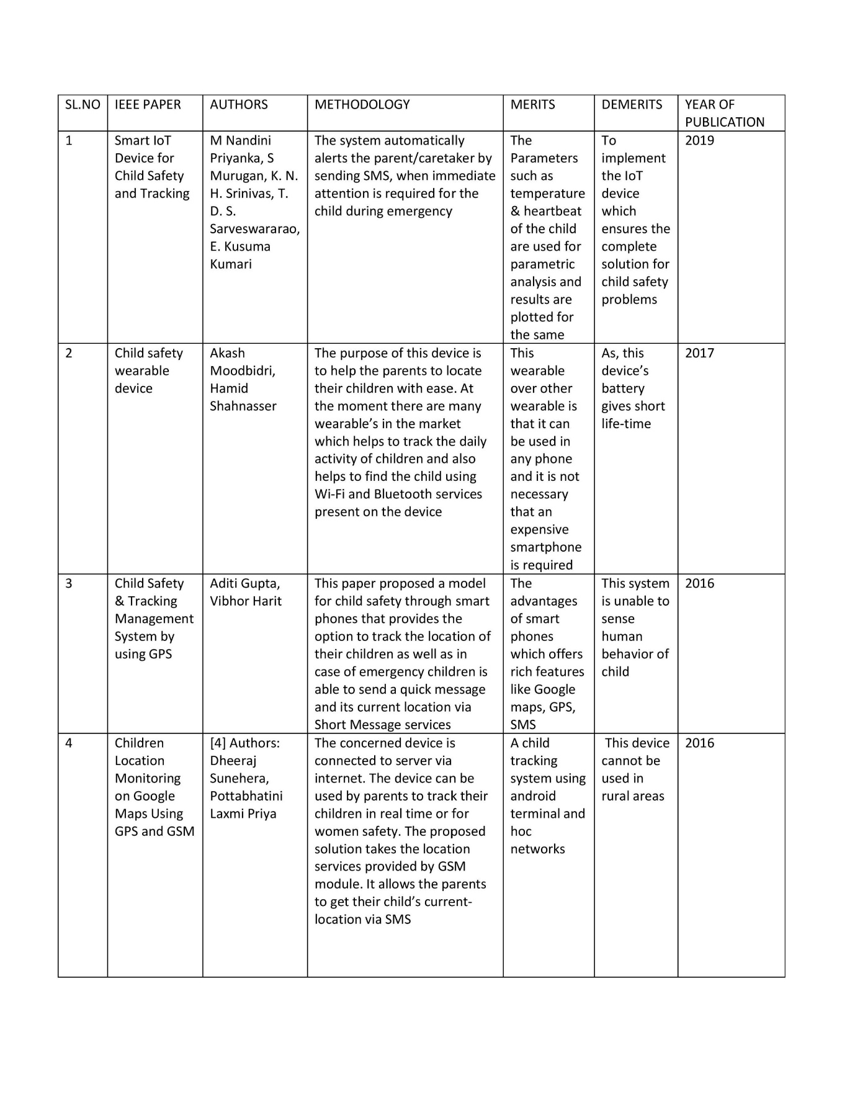

**2.2.References**

1. Starner, T Schiele, B and Pentland, A. (1998) ‘Visual contextual awareness in wearable computing’, Second International Symposium on Wearable Computers, Pittsburgh, PA, IEEE Computer Society, pp. 50-57.

2. AkashMoodbidri, Hamid Shahnasser (Jan 2017) ‘Child safety wearable device’, International Journal for Research in Applied Science & Engineering Technology, Vol. 6 Issue II, IEEE, pp. 438- 444.

3. AsmitaPawar, PratikshaSagare, TejalSasane, KiranShinde (March– 2017) ‘Smart security solution for women and children safety based on GPS using IOT’, International Journal of Recent Innovation in Engineering and Research, vol. 02, Issue. 03, pp.85-94.

4. Nitishree, (May-June, 2016) ‘A Review on IOT Based Smart GPS Device for Child and Women Safety’, International Journal of Engineering Research and General Science, Vol.4, Issue. 3, pp. 159- 164.

5. Kok Sun Wong, Wei Lun Ng, Jin Hui Chong, CheeKyun Ng, AduwatiSali, Nor KamariahNoordin, (15 -17 )December 2009) ‘GPS Based Child Care System using RSSI Technique’, Proceedings of the Malaysia International Conference on Communications. pp. 899-904.

**2.3.Problem Statement Definition**

Child safety and tracking is a major concern as the more number of crimes on children are reported nowadays. With this motivation, a smart IoT device for child safety and tracking is developed to help the parents to locate and monitor their children.

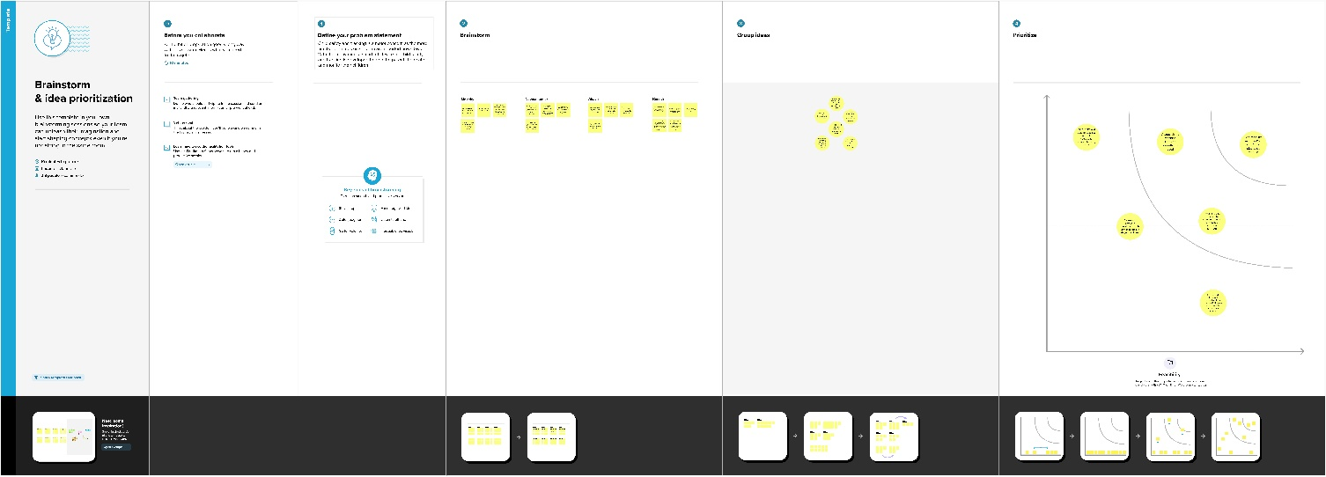

**3.IDEATION & PROPOSED SOLUTION**

**3.1.Empathy Map Canvas**

In this activity we are expected to prepare the empathy map canvas to capture the user Pains & Gains, Prepare list of problem statements.

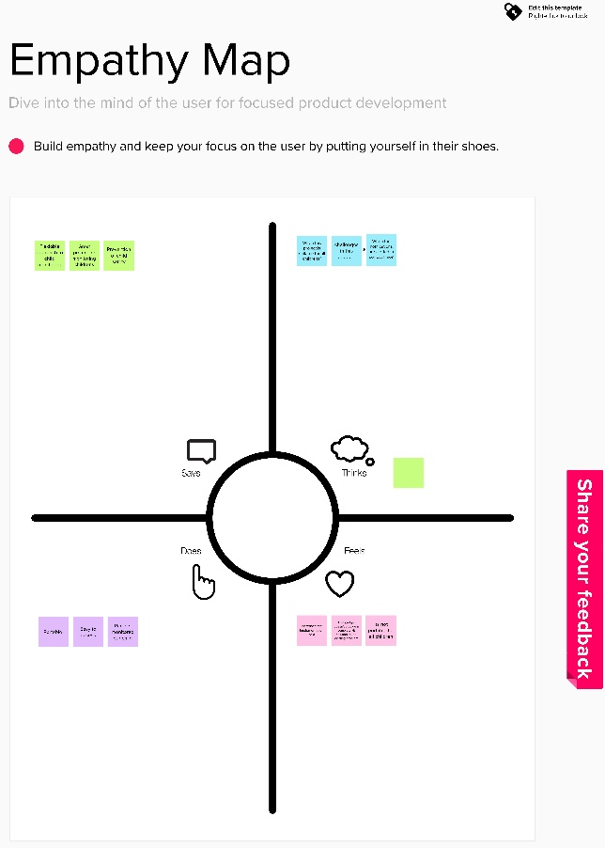

**3.2.Ideation & Brainstorming**

In this activity we are expected to list the ideas by organizing the brainstorming session and prioritize the top 3 ideas based on the feasibility & importance.

**Step-1: Team Gathering, Collaboration and Select the Problem Statement**

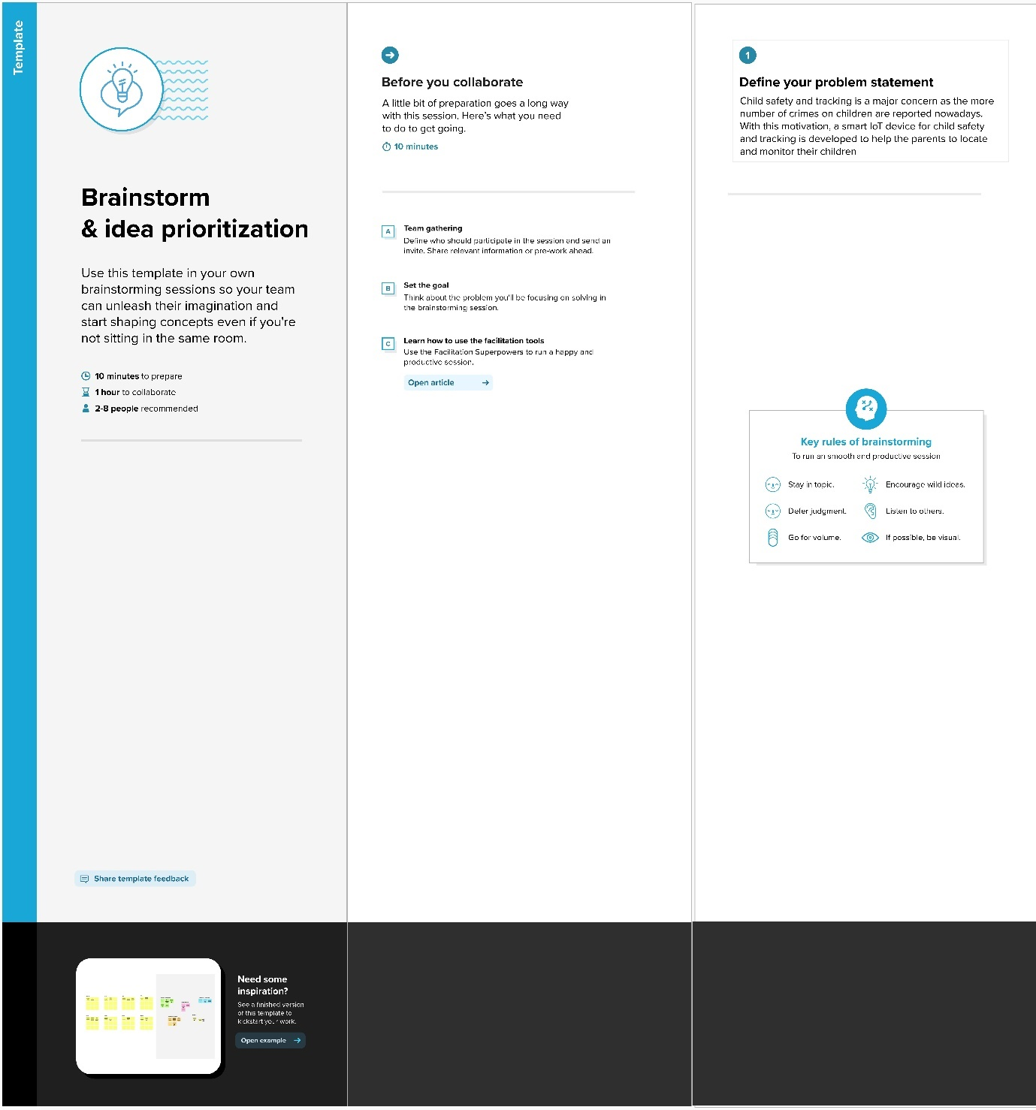

**Step-2: Brainstorm, Idea Listing and Grouping**

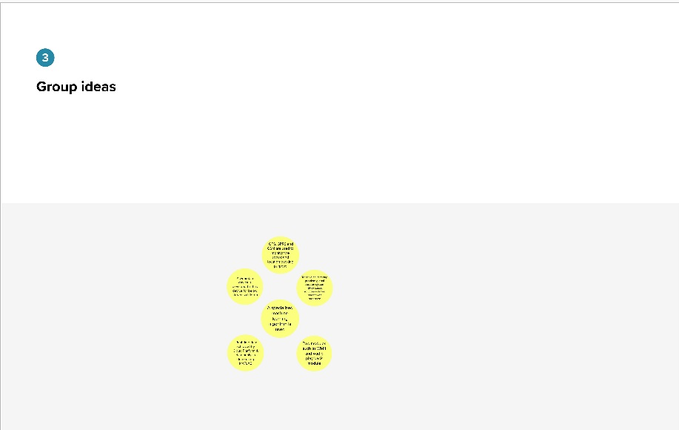

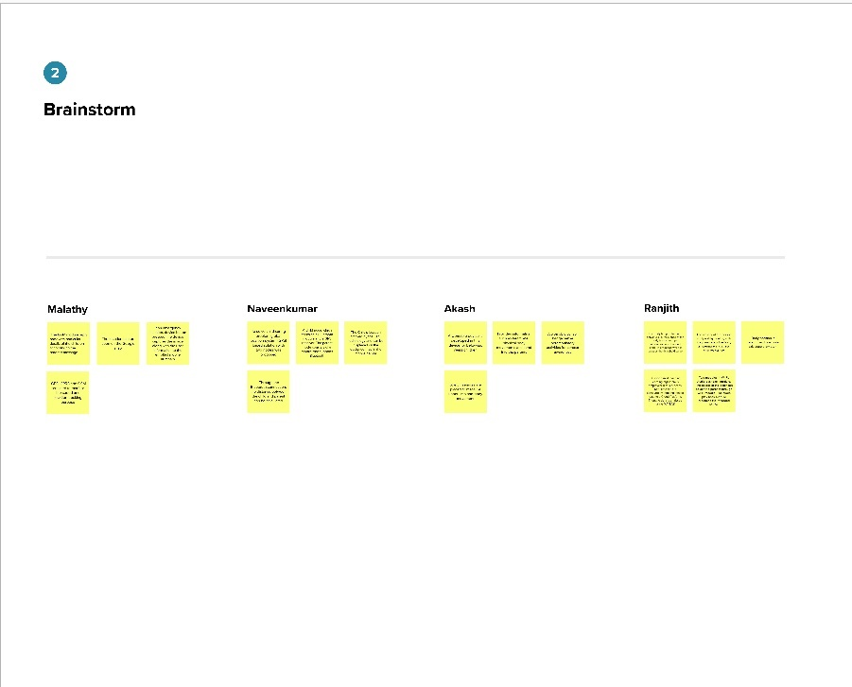

**Step-3: Idea Prioritization**

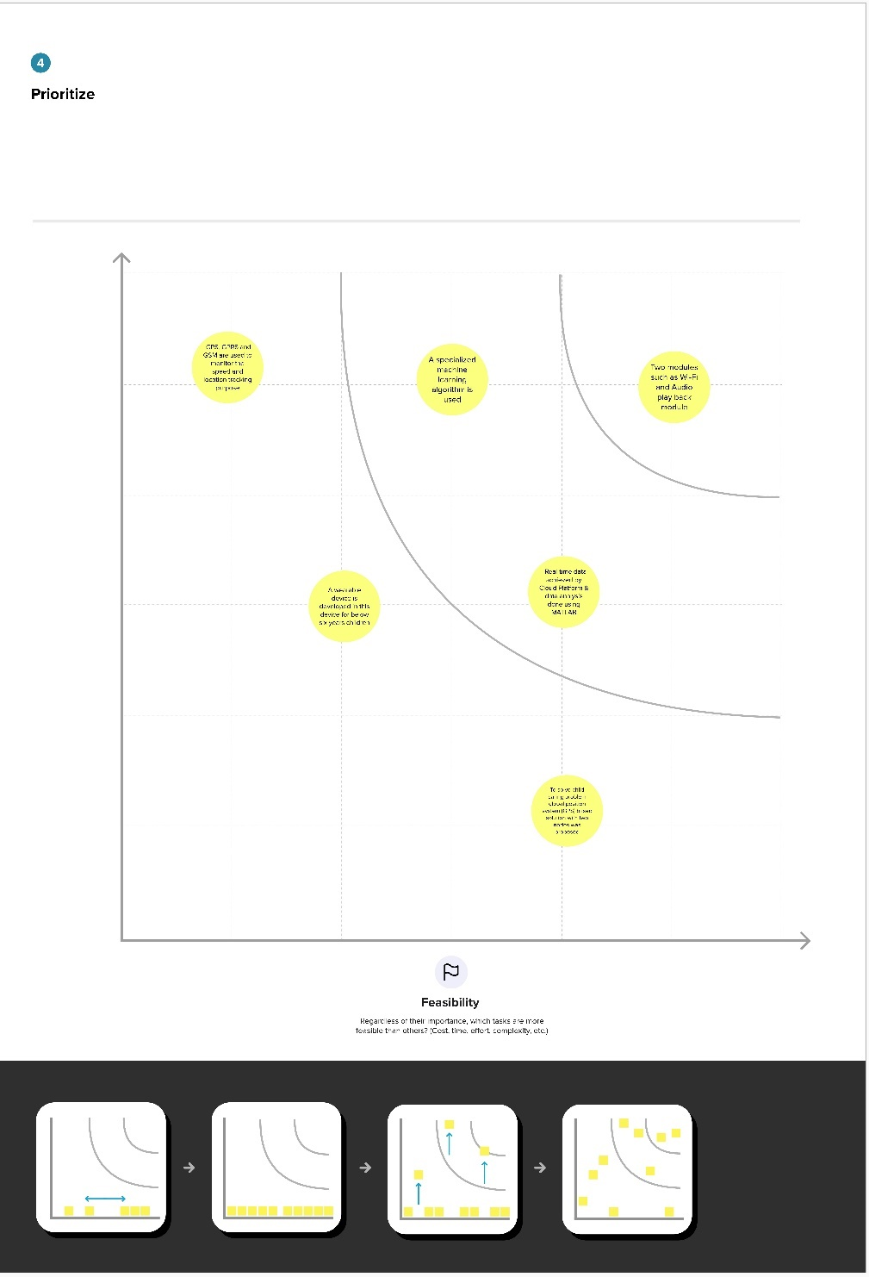

**3.3.Proposed Solution**

Project team shall fill the following information in the proposed solution template.

The counter should be started for counting time. The sensors output data should be read from the child safety device. The counter time should be checked for time interval of 30minutes. For every 30minutes except serial camera, the data from GPS, temperature, touch, pulse rate data is pushed into the cloud. The monitoring parameters are displayed on webpage. The counter is reset to restart the timer. So as to post the data into the cloud for every 30minutes. The sensors data is continuously read by the controller. When the value of temperature read from the sensor crosses the threshold1, notification messages are sent. The threshold value of the temperature is considered here is 38°C. Similarly, when the touch sensor value is crocess threshold2, notification messages are sent. Threshold of the touch sensor is considered here is 100. The Pulse rate intervel is analog value from the sensor, it is converted into the beats per minute (BPM) by formulae.

Flow chart of the proposed system,

BPM = (1.0/Pulse Intervel) * 60.0 * 1000

The pulse rate intervel and the BPM are inversely proportional to each other. If the pulse rate intervel of the child decreases then BPM increases. Pulse rate of the Child is less than the threshold3, then device gives an notification message to the parents mobile phone. After notification message an MMS is sent to mobile phone module which consists of an image indicating the surrounding area of the child. Three throusholds are used threshold1 is 38°C for Temperature sensor, threshold2 is 100 for Touch sensor and threshold3 is 400 for Heartbeat sensor.

**3.4.Problem Solution fit**

The LinkIt ONE board is an open source platform. It consists of inbuilt Wi-Fi, GSM, GPS and Bluetooth modules. The link it one board is similar to the arduino board and it is termed as all-in-one prototyping board for wearable’s and IoT devices. The board consists of ARM7 EJ-S and the clock speed is 260MHz. A SIM and SD card slots are provided on the board itself. For the audio purpose a headset slot is also provided. The link it one is a robust development board for the hardware and also used for industrial applications. Different components such as Temperature sensor, Touch sensor, heartbeat sensor, GSM, GPS modules and serial camera are connected to the LinkIt ONE Board along with built in GSM, GPS modules.

Lithium ion battery is used as DC supply required to energize it. A rechargeable battery can also be used for the above purpose. Temperature sensor block is shown in figure 1; temperature is one of the most commonly measured variables and is therefore there are many ways of sensing temperature.

For measuring body temperature of the child LM35 temperature sensor is used. The touch sensor has three main components on the circuit board. The first component comprises of resistors, transistors, capacitors, inductors, and diodes whose area is measured physically and its analogue signal is sends to an amplifier. Depends upon the resistant value of the potentiometer the amplifier amplifies the signal and sends the signal to analogue output of the module. The third component is comparator, when the signal falls under a specific value it is used to switch the output. A serial camera is used for the purpose of taking snapshot of the area surrounding the child.

A miniature TTL serial JPEG camera is used because it is the best one for the purpose of wearable type. The camera can snap the images of different sizes of pixels and those images are pre-compressed into JPEG images. The heartbeat sensor is used in the proposed system for measuring the pulse rate. There is a heartbeat pulse sensor which is combined to simple optical heart rate sensor with amplification and nullification circuitry making it is fast and easy to get reliable pulse reading. The GSM/GPRS block is activated with a SIM card on the board. GSM standard used here is GSM900. They mainly differ‘s based on bandwidth and RF carrier frequency.

GSM network consists of mobile station, Base station subsystem network and operation subsystem. The GPS module is provided for identifying the location of the child. GPS module receives the signals from satellites which are located miles away. The latitude and longitude of the location can be identified by the GPS module.

The Link it ONE board consists of micro SD/SIM combo. The device sends the monitored parameters data such as Temperature, touch and pulse rate to cloud. When there are any abnormalities in temperature or touch or pulse rate readings, a SMS is sent to the parent/caretaker mobile phone immediately. After sending SMS the serial camera captures thesnapshot in real time and is stored in SD card. From the SD card through the GSM module an MMS is sent to the particular mobile phone.

**3.4.1. Pulse Rate formula:**

BPM = (1.0/Pulse Intervel) * 60.0 * 1000

Pulse rate in graph of adult person = 735 BPM

= (1.0/735) * 60.0 * 1000 BPM

= 81.63

If the pulse rate of the child decreases then BPM increases. Whenever the pulse rate value is less than 400 then automatically sent an SMS alert to the mobile and also an MMS is sent to parent mobilemodule which consists of an image indicating the surrounding area of the child.

**4.REQUIREMENT ANALYSIS**

**4.1.Functional requirement**

Following are the functional requirements of the proposed solution.

**System Required :** RAM-Minimum 4GB Processor-Min.

**Configuration OS** : Windows/Linux/MAC.

**Software Required:** Python IDLE.

# **4.2.Non-functional Requirements**

Following are the non-functional requirements of the proposed solution.

* + - Node-RED.
    - Web UI.
    - Cloudant DB.
    - Geofence.

**5.PROJECT DESIGN**

**5.1.Data Flow Diagrams**

A Data Flow Diagram (DFD) is a traditional visual representation of the information flows within a system. A neat and clear DFD can depict the right amount of the system requirement graphically. It shows how data enters and leaves the system, what changes the information, and where data is store

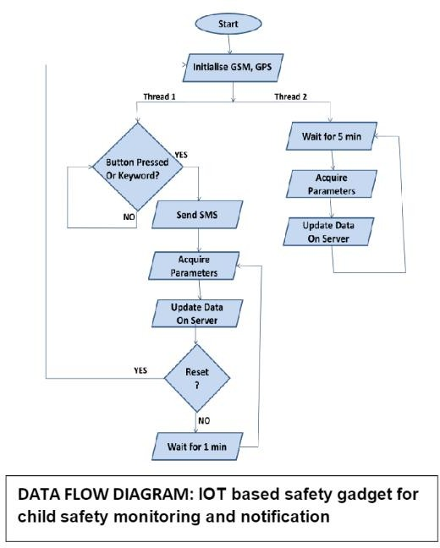

**5.2.Solution & Technical Architecture**

**5.2.1.Technical Architecture**

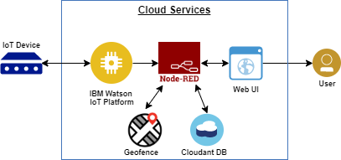

**Table-1.Components and Technologies:**

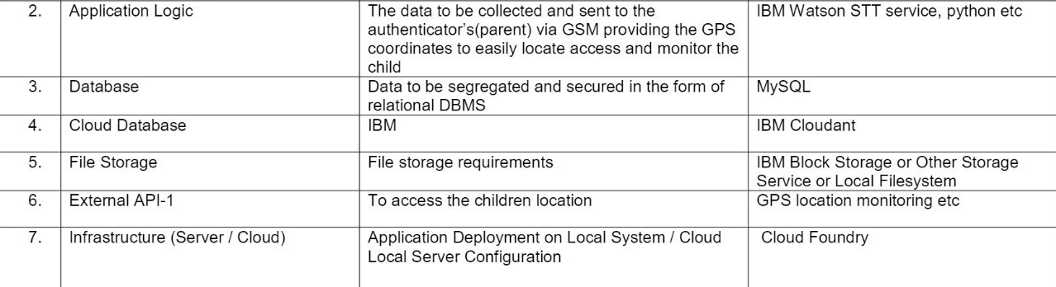

**Table-2: Application Characteristics:**

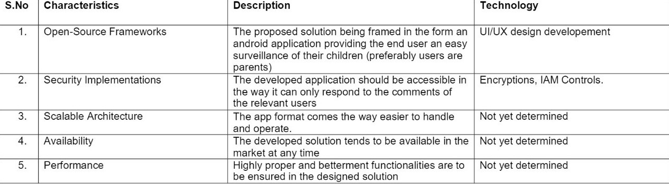

**5.2.2.Solution Architecture**

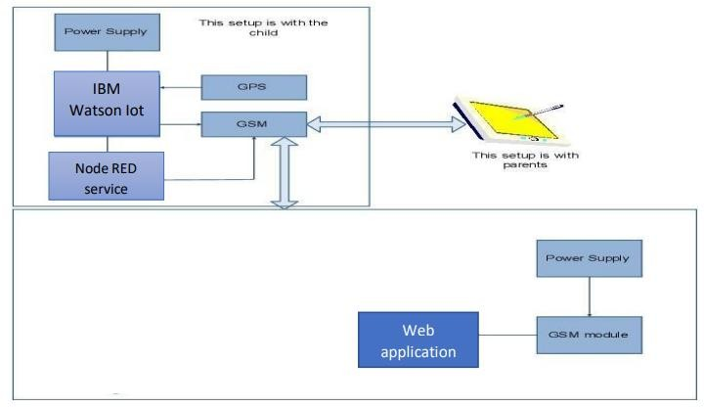

**5.3.User Stories**

|  |  |  |  |  |  |  |
| --- | --- | --- | --- | --- | --- | --- |
| **User Type** | **FunctioalRequirement (Epic)** | **User Story Number** | **User Story / Task** | **Acceptance criteria** | **Priority** | **Release** |
| Customer (Mobile user) | Dashbord | USN-1 | As a user, I can view the Child’s exact location and  Know the information about whether child present in the Geofence | I can access the Child’s Location/ Geofence Notification | High | Sprint-1 |
| Customer (Web user) | Dashboard | USN-1 | As a user, I can view the Child’s exact location and  Know the information about whether child present in the Geofence | I can access the Child’s Location/ Geofence Notification | High | Sprint-1 |
| Administrator | Login | Admin-1 | As a admin,I can log in to the IBM account by using authorized userID and password | I can access the Child’s Location/ Geofence Notification | High | Sprint-1 |
|  | Upload | Admin-2 | As a admin,I can log in into my account and use the cloud object storage service of the IBM cloud to store and retrieve the child’s location information, whenever it is needed. | I can access my cloud storage | High | Sprint-1 |
|  | Visualize | Admin-3 | As a admin,I can use the cloud object storage service of the IBM cloud to store and retrieve the child’s location information,whenever it is needed and help the user according to the situation. | I can visualize my data | High | Sprint-2 |

**6.PROJECT PLANNING & SCHEDULING**

**6.1.Sprint Planning & Estimation**

|  |  |  |
| --- | --- | --- |
| **Title** | **Description** | **Date** |
| **Literature survey and Information gathering** | Literature survey | 16 Oct 2022 |
| **Prepare Empathy Map** | Empathy map canvas | 20 Sept 2022 |
| **Ideation** | Brainstorm | 18 Oct 2022 |
| **Proposed solution** | Proposed solution | 16 Oct 2022 |
| **Problem solution fit** | Problem solution fit Document | 15 Oct 2022 |
| **Solution Architecture** | Solution Architecture | 15 Oct 2022 |
| **Customer journey** | Customer journey maps | 29 Oct 2022 |
| **Functional requirements** | Functional requirements | 18 Oct2022 |
| **Data flow diagrams** | Data flow diagrams | 16 Oct 2022 |
| **Technology Architecture** | Technology architecture | 17 Oct 2022 |
| **Prepare Milestone and Activity List** | Milestone and activity list | 15 Nov 2022 |
| **Sprint Delivery plan** | Sprint delivery | 16 Nov 2022 |
| **Project Development- Delivery of sprint-1,2,3 & 4** | Developing code | 18 Nov 2022 |

**6.2.Sprint Delivery Schedule**

Sprint planning is an event in scrum that kicks off the sprint. The purpose of sprint planning is to define what can be delivered in the sprint and how that work will be achieved. Sprint planning is done in collaboration with the whole scrum team

**6.2.1.Product Backlog, Sprint Schedule, and Estimation:**

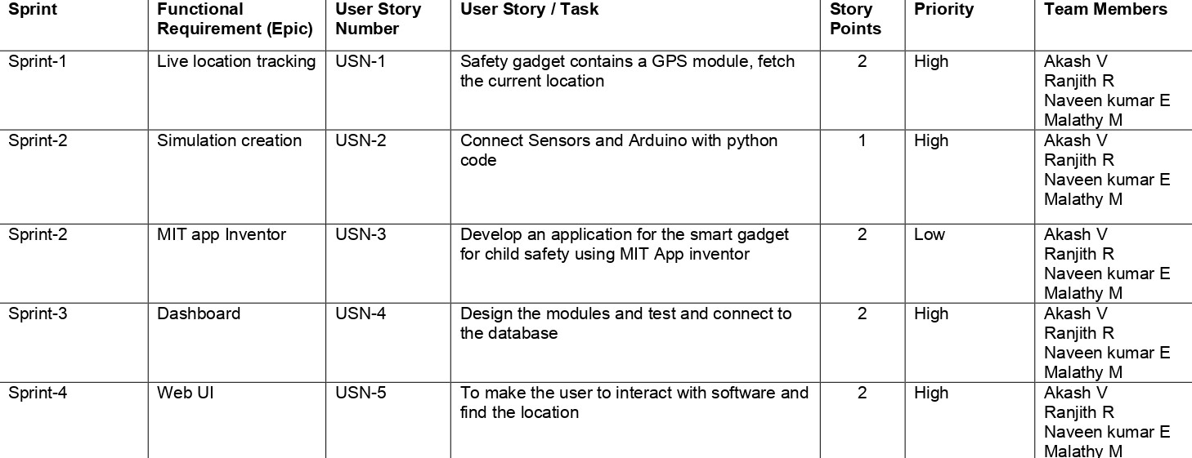

**6.2.2.Project Tracker, Velocity & Burndown Chart**

|  |  |  |  |  |  |  |
| --- | --- | --- | --- | --- | --- | --- |
| **Sprint** | **Total Story Points** | **Duration** | **Sprint Start Date** | **Sprint End Date (Planned)** | **Story Points Completed (as on Planned End**  **Date)** | **Sprint Release Date (Actual)** |
| Sprint-1 | 5 | 6 Days | 24 Oct 2022 | 29 Oct 2022 | 5 | 29 Oct 2022 |
| Sprint-2 | 8 | 6 Days | 31 Oct 2022 | 05 Nov 2022 | 8 | 05 Nov 2022 |
| Sprint-3 | 8 | 6 Days | 07 Nov 2022 | 12 Nov 2022 | 8 | 12 Nov 2022 |
| Sprint-4 | 16 | 6 Days | 14 Nov 2022 | 19 Nov 2022 | 16 | 19 Nov 2022 |

**Velocity:**

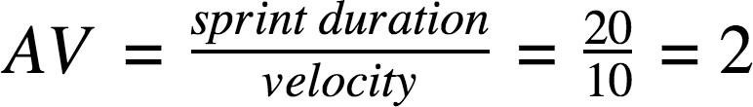 Imagine we have a 10-day sprint duration, and the velocity of the team is 20 (points per sprint). Let’s calculate the team’s average velocity (AV) per iteration unit (story points per day).

|  |  |  |  |
| --- | --- | --- | --- |
| **Sprint** | **Story points** | **Duration** | **Average velocity** |
| **Sprint-1** | 5 | 6 | 0.83 |
| **Sprint-2** | 8 | 6 | 1.33 |
| **Sprint-3** | 8 | 6 | 1.33 |
| **Sprint-4** | 16 | 6 | 2.66 |
| **Total** | 37 | 24 | 1.54 |

**6.3 Reports from JIRA**

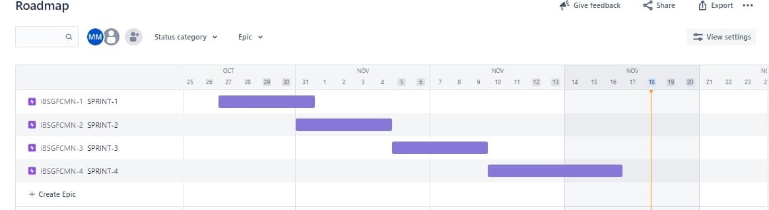

**Sprint-1**

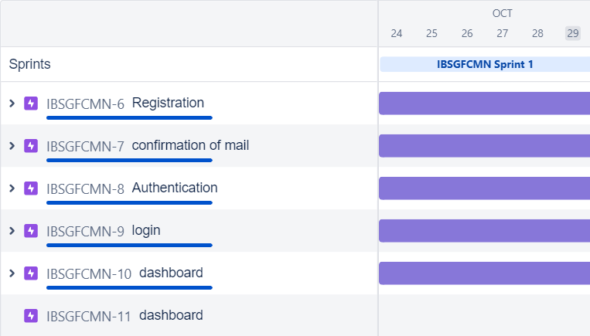

**Sprint-2**

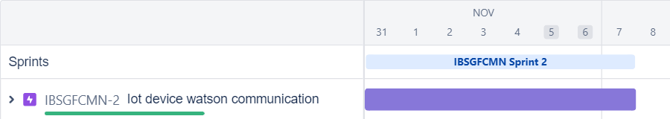

**Sprint-3**

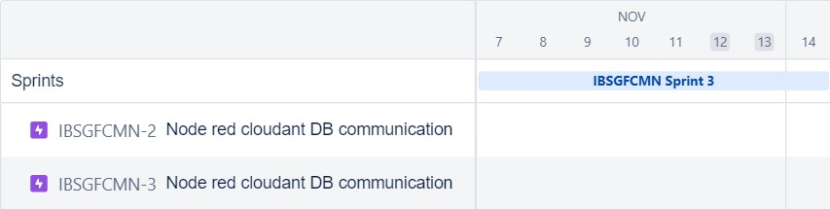

**Sprint-4**

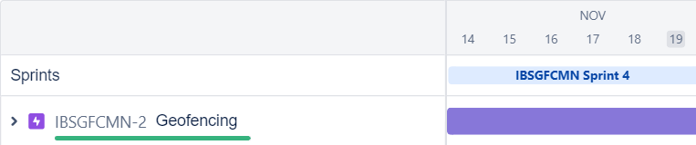

**7.CODING & SOLUTIONING**

**7.1.Features 1**

**1.Live Location Tracking:**

GPS is installed on gadget to track its current location can be tracked on android app and via SMS request sent from parent phone to safety gadget. Fig. 3. Outputs of live location tracking.

**2. Panic Alert Systems:**

Panic alert system on gadget is triggered during panic situation, automatic call and SMS are triggered to parental phone. The alert is also updated to the cloud for purpose of app monitoring. Fig. 4. Outputs of panic alert system.

**3.Stay Connected Feature:**

Stay connected feature is used to trigger call and pre-defined SMS anytime from gadget to parental phone by just pressing a button and also parent can make SMS and call to the gadget anytime.

**7.2. Features 2**

**1. Health Monitoring System:**

Health monitoring system is implemented using heart beat sensor, temperature sensor which is updated to the cloud and also can be monitored via app. The current value of sensors can be obtained using SMS request sent to gadget from parent phone.

**2.Gadget Plugged or Unplugged Monitoring:**

Gadget plug or unplugged is monitored using contact switch installed on smart gadget, as soon as the device is unplugged, an alert is provided to parent phone via SMS and it is also updated to cloud for app monitoring.

**3. Boundary monitoring system:**

This is used to track the safety gadget using the binding gadget by implementing signal strength concept as soon as the safety gadget moves far away from the BLE listener gadget then an alert is provided to itself.

**7.3.Database Schema**

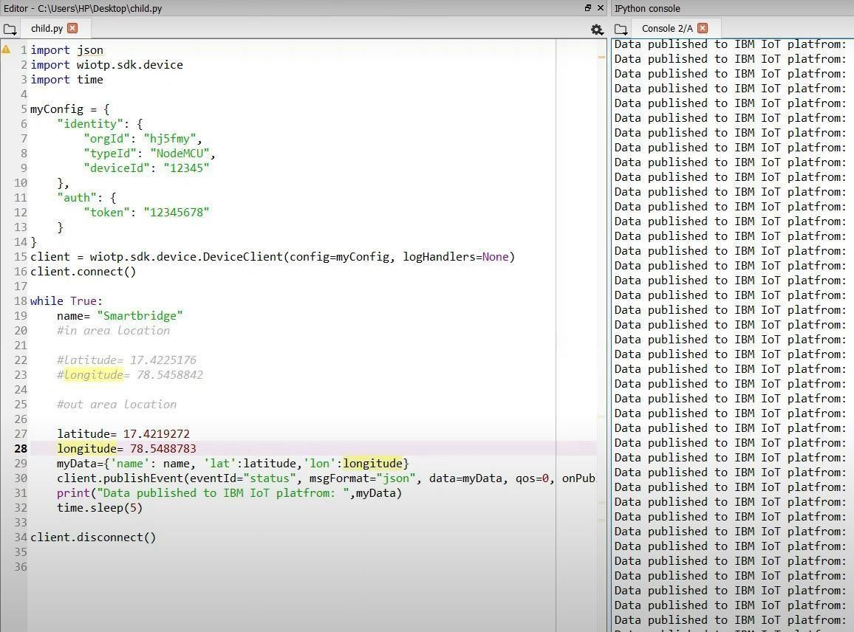

**8. TESTING**

**8.1 Test Cases**

**1. Application level:**

This level deals with all the activities of sale like sale of an item, available discount, coupons, payment, receipt printing, more precisely functions of application level is sales and payment.

Types of testing used at this level are as:

* **Functionality Testing:**

It is a type of testing which test that all functions of the application are working as per the requirements of the system. In the POS system, testers validate the working of all functions using functionality testing, the functions which the POS system performs are printing receipt of the purchased item, returning an item, selling, scanning an item for its price and available discount, and payment.

* **Compatibility Testing:**

This testing is non-functional testing that is used to test whether the system is capable to work with other OS, hardware, software, mobile devices, etc. As the POS system is connected to several hardware components so testers test compatibility with all hardware and a new version of OS.

* **Payment Gateway Testing:**

POS system supports online payment modes of the transaction so it needs to follow PCI complaints. Testers validate that the system is working successfully with various payment modes.

**2. Enterprise Level:**

The enterprise level is a broad term that deals with functions like payrolls, total transaction throughout the day, offers which attracted a large number of customers, database management, inventory list management, and accounts management.

**Type of testing used at this level are as:**

* **Performance Testing:**

It is a type of testing which test the performance of the system in terms of response time, working with connected devices, speed, and scalability when workload increases. POS system goes through this testing to validate the responsiveness of the system and when the system crash if the load increases.

* **Interoperability Testing:**

POS system operates on various software and hardware, and testers validate that the system is interacting with other related software and hardware as per requirements.

* **Compliance Testing:**

It is also called conformance testing, it is used to determine that the application meets all the set standards. The POS system offers credit and debit card payment modes so. it needs to fulfill all the parameters set by PCI standards for payments, testers validate that the system is following all those set standards.

* **Data Migration Testing:**

This form of testing is used when data is migrated from the original database to the new database storage system, it validates that all data is replaced without any loss of data, and no duplicate data is made.

* **Upgradation Testing:**

This form of testing determines that the new versions of the software are compatible to upgrade the old version of the system. A POS system needs to be upgraded with a new OS, software, and hardware version so testers validate that the system can be timely upgrade and support new features to remain in the race of changing technology with time.

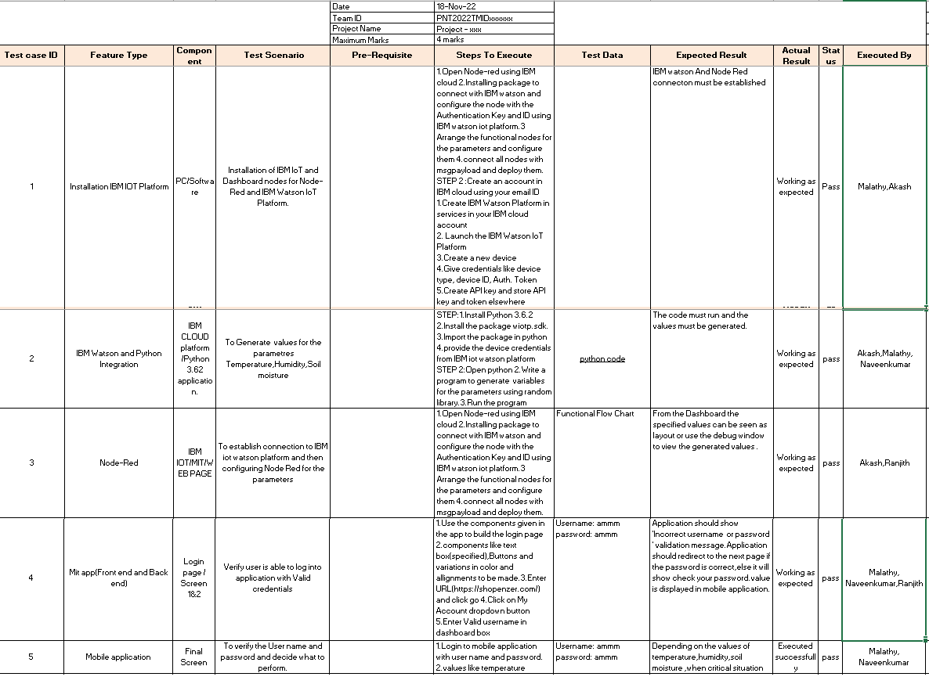

**8.2 User Acceptance Testing**

**User Acceptance Testing (UAT), also known as beta or end-user testing, is defined as testing the software by the user or client to determine whether it can be accepted or not*.***This is the final testing performed once the functional, system and regression testing are completed.

The main purpose of this testing is to validate the software against the business requirements. This validation is carried out by the end-users who are familiar with the business requirements.

UAT, [alpha and beta testing](https://www.softwaretestinghelp.com/what-is-alpha-testing-beta-testing/) are different types of acceptance testing.

As the user acceptance test is the last testing that is carried out before the software goes live, obviously this is the last chance for the customer to test the software and measure if it is fit for the purpose.

### When Is It Performed?

This is typically the last step before the product goes live or before the delivery of the product is accepted. This is performed after the product itself is thoroughly tested.

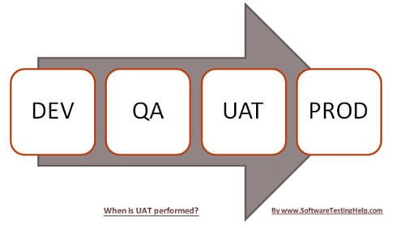

### Who Performs UAT?

Users or client – This could be either someone who is buying a product (in the case of commercial software) or someone who has had a software custom-built through a software service provider or the end-user if the software is made available to them ahead of the time and when their feedback is sought out.

The team can be comprised of beta testers or the customer should select UAT members internally from every group of the organization so that each and every user role can be tested accordingly.

**9. RESULTS**

**9.1 Performance Metrics**

**1.Live Location Tracking:**

GPS is installed on gadget to track its current location can be tracked on android app and via SMS request sent from parent phone to safety gadget. Fig. 3. Outputs of live location tracking.

**2. Panic Alert Systems:**

Panic alert system on gadget is triggered during panic situation, automatic call and SMS are triggered to parental phone. The alert is also updated to the cloud for purpose of app monitoring. Fig. 4. Outputs of panic alert system.

**3.Stay Connected Feature:**

Stay connected feature is used to trigger call and pre-defined SMS anytime from gadget to parental phone by just pressing a button and also parent can make SMS and call to the gadget anytime.

**4. Health Monitoring System:**

Health monitoring system is implemented using heart beat sensor, temperature sensor which is updated to the cloud and also can be monitored via app. The current value of sensors can be obtained using SMS request sent to gadget from parent phone.

**5.Gadget Plugged or Unplugged Monitoring:**

Gadget plug or unplugged is monitored using contact switch installed on smart gadget, as soon as the device is unplugged, an alert is provided to parent phone via SMS and it is also updated to cloud for app monitoring.

**6. Boundary monitoring system:**

This is used to track the safety gadget using the binding gadget by implementing signal strength concept as soon as the safety gadget moves far away from the BLE listener gadget then an alert is provided to itself.

**10.ADVANTAGES & DISADVANTAGES**

**10.1. ADVANTAGES**

* Keeps track of children in case of abduction.
* Allows children more freedom while being watched.
* Monitors children with special needs who wander.
* Helps monitor children with behavioural problems.
* Gives peace of mind to parents.

**10.2. DISADVANTAGES**

* Children may feel a loss of privacy.
* Losing confidence.
* The system is dependent on communication signal/network signal for the smart gadget to trigger automatic phone call/SMS during panic situation.
* It can be difficult to detect when network signal is not reachable/weak/when the smart gadget moves outside the boundary range.
* Improved by increasing the range.

**11.CONCLUSION**

The word Future resembles the word Children. As Dr. A.P.J Abdul Kalam’s words “Youngsters are the future pillars of one’s nation", today's children are tomorrow's youngsters, preserving their dreams and life for a better future is necessary. Therefore, each and every parent should take care of their own children, without letting them to fall into the dark world of abusements, which entirely ruin them physically, mentally and emotionally destroying our future. Hence, considering the importance of our future, our project makes it easy for parents to track their children and to visually monitor them on regular basis, which makes them ensure the safety of their children and reduces the rate of incidents of child abuse. This research demonstrates Smart IoT device for child safety and tracking, to help the parents to locate and monitor their children. If any abnormal readings are detected by the sensor, then an SMS and phone call is triggered to the parents mobile. Also, updated to the parental app through the cloud. The system is equipped with GSM and GPS modules for sending and receiving call, SMS between safety gadget and parental phone. The system also consists of Wi-Fi module used to implement IoT and send all the monitored parameters to the cloud for android app monitoring on parental phone. Panic alert system is used during panic situations alerts are sent to the parental phone, seeking for help also the alert parameters are updated to the cloud. Boundary monitoring system is implemented on safety gadget with the help of BEACON technology, as soon as the safety gadget moves far away from the BLE listener gadget an alert is provided to itself.

**12.FUTURE SCOPE**

* + This system can be further enhanced by installation of mini-camera inside smart gadget for better security so that live footage can be seen on parental phone during panic situations.
  + The system can be modified by installation of small solar panels for charging the battery of smart gadget to gain maximum battery backup.

**13.APPENDIX**

**13.1. Source Code**

**Simulation code**

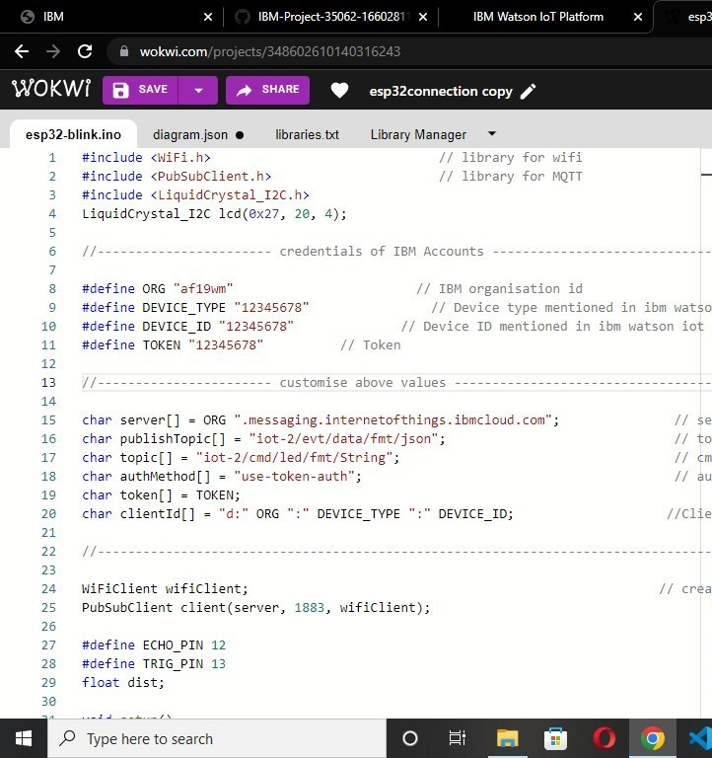

**Simulation Output:**

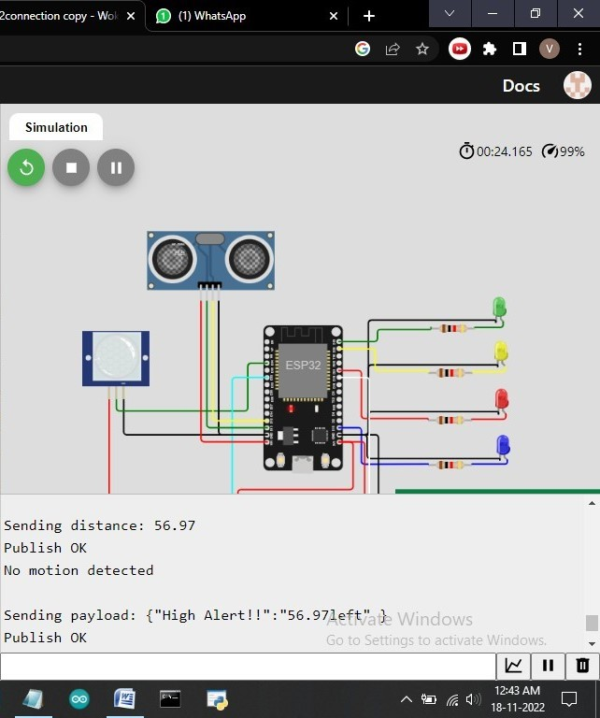

# 

# **Develop The Web Application Using Node-RED**

1. To Develop the web application using Node-RED

**Steps :**

Open a Node-RED project:

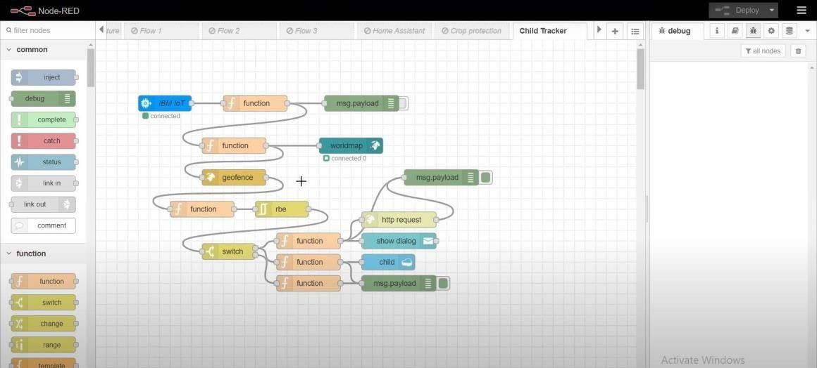

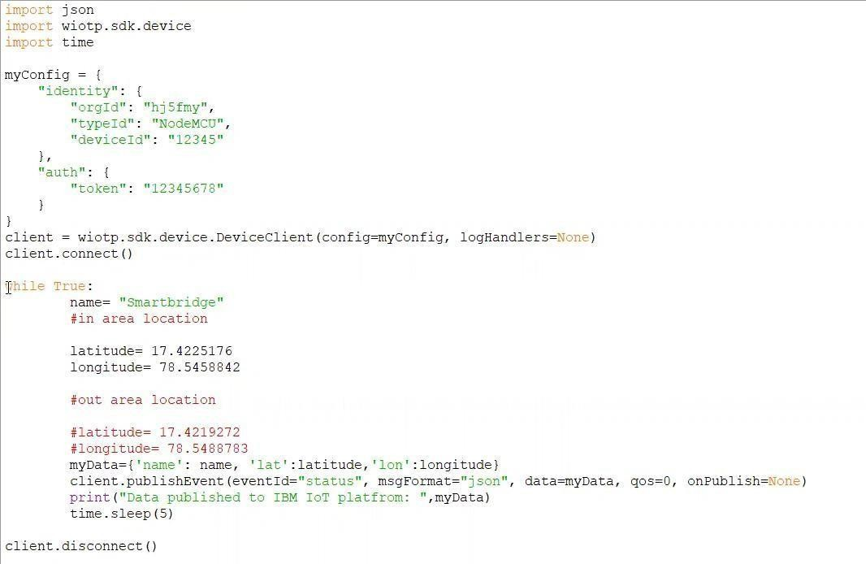 Add code to get child location in python:

Create the Geo-Fence: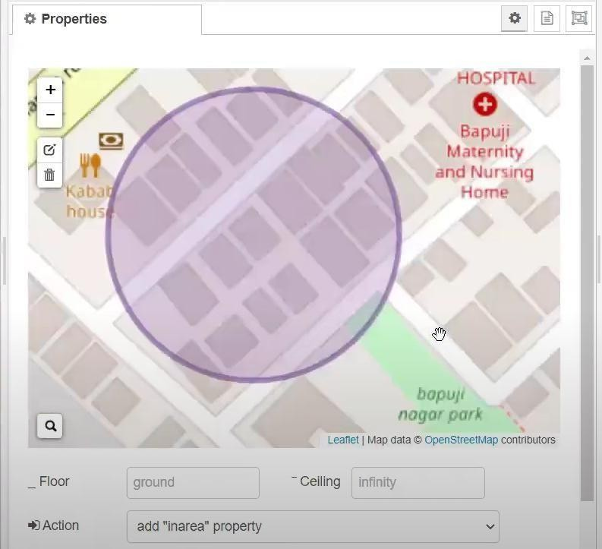

Edit the HTTP Request URL:

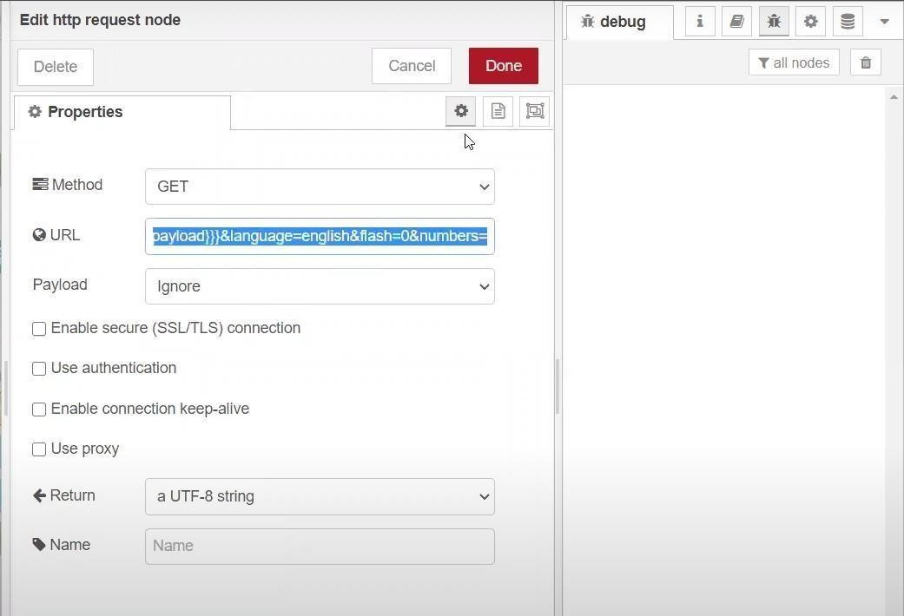

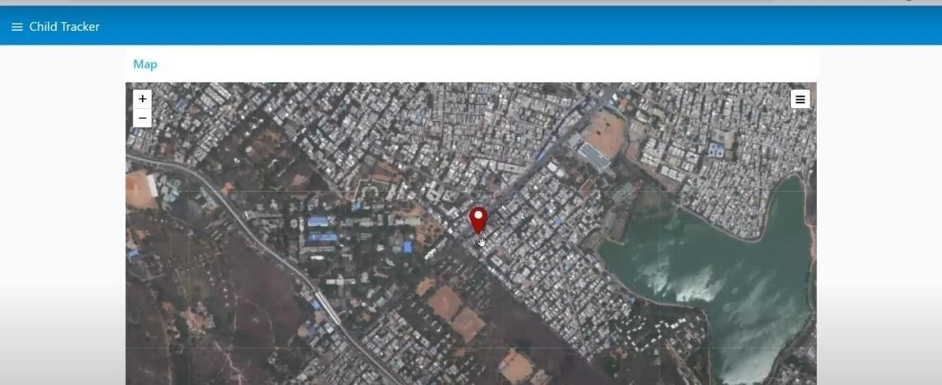Locate the child:

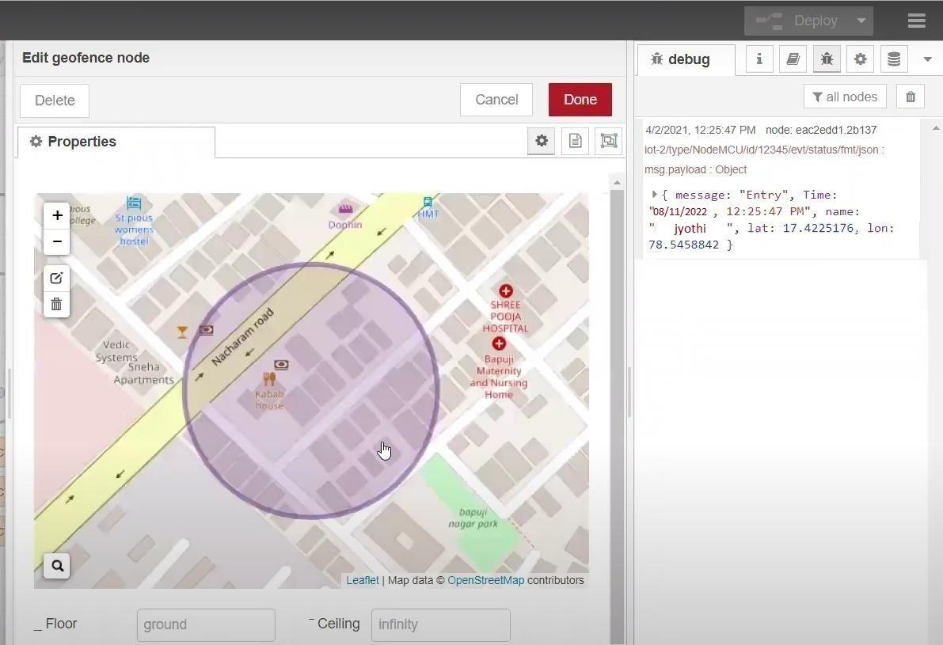 Create the Geo-fence node:

Python script send requests to IBM Cloud:



After running the script, the web UI shows “Person is not in the particular area”.

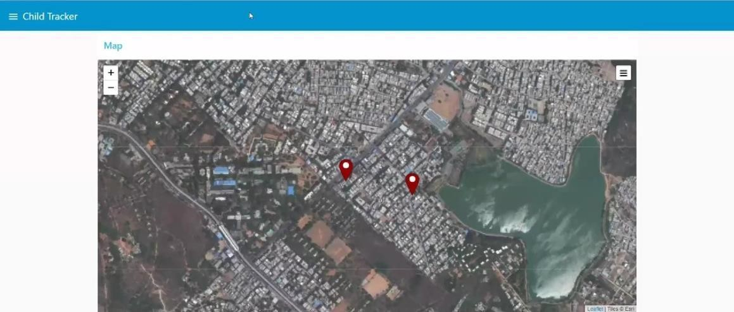

The web application developed using Node-RED Successfully.

**13.2.GitHub & Project Demo Link**

**GitHub Link:**

[**https://github.com/IBM-EPBL/IBM-Project-38507-1660381737**](https://github.com/IBM-EPBL/IBM-Project-38507-1660381737)